
Featherstone News
https://www.featherstonenurseryschool.co.uk JUNE 2026
Dates for your diary:
Thursdays: Stay and Play (under 2s) every Thursday morning – 9:45 – 11:15am at OSBORNE NURSERY SCHOOL.
Monday 25th May – Friday 29th May – HALF TERM
Wednesday 10th June Little Learners Park Trip –
Wednesday 17th June - Explorers trip to the park in Lichfield.
WC 29th June – Parent/ carer meetings to discuss your child’s progress and next steps
Wednesday 8th July – Osborne Nursery School 50 years celebration! Previous pupils and staff are welcome to visit at 4pm
WC: 13th July – Transition Celebrations!
Friday 17th July – last day of the summer term
Please remember to telephone us on 675 3408 if your child is too ill to be at nursery.

Nursery News:
Explorers went for a walk to our local shop. During the walk the children looked for numbers along the route. They saw lots of examples of numbers – bus stops, schools and numbers on houses. They saw so many numbers in the shop! Thank you to all of the parents that joined us!
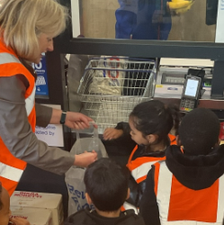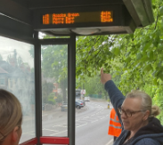
Look at out Forest School Skills! We have been using the bow saw this week.
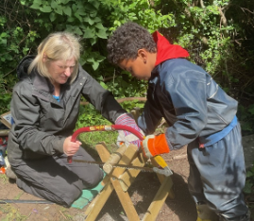
We were like our Startwell character Sammy Skills practicing our manipulative skills whilst using the tools and practicing undressing and dressing ready for forest school.

Attendance is very important at Nursery. We like to see you for all your sessions each week. We like families to aim for attendance to be between 95 and 100%. Look out for the Cool Kittens stickers
Congratulations to CATERPILLARS and HEDGEHOGS with LIZ for the best attendance in Nursery in May 2026. FANTASTIC!! Well done to the parents and carers too.

The hatching experience: What an amazing time we had with the ducklings! The children have learnt so much about life cycles and how to care for the ducklings. All the ducklings were collected by the farmer who has taken them back to his farm. Some of the ducklings will stay with him and others will be adopted into new families. We are sure they will be very happy.
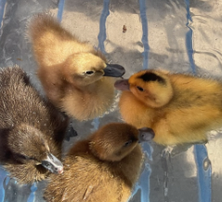






This year we will be working towards reaccrediting our Rights Resecting Award. You will have seen our posts about ‘ I have the right to be safe’
Terry the Tiger is helping the children understand their rights and use the language of rights. When is your turn to take Terry home?!

It is half term next week – what will you get up to?! Please share the activities that you do as a family that link to the right to relax and play.

We need to keep our children safe and help them to understand how to play games, use the internet and different devises safely.
A simple and effective way to get involved with your children and their lives online is through discussion. By maintaining an open dialogue with your child and encouraging them to talk to you about their internet use parents can help children access the amazing resources the internet has to offer whilst keeping them safe online.

This month’s recommended reads are: Timothy Pope has a brand-new telescope and he's testing it out in the park. Peep through the die-cut holes in this book to see if you can spy a shark. Is that really a shark? What will we see in the park on our park trips?!
Remember to bring in your money and permission forms for our park trip – this to pay for our train fare. So exciting!


Transition:
It will soon be time for some of our children to move up to their new schools or groups in nursery. We have planned lots of activities to support your child’s transition. Please see your key worker for further tips!

Here are some top tips for home:
- Talk about their new school – draw pictures or talk about what they will be doing
- Talk about how they are feeling. It’s good to express feelings.
- What changes have they experienced in the past? ( New baby, new home?)
- Take a walk past their new school, talk about the route.
- Practice putting coats on and off and doing up zips/ press studs / buttons.
- Recognising their name
- Have fun with counting!
- Check the new school website

Half term.
We would like to wish you a very safe and happy half term. Well done to all the new children that have settled so well! Birmingham has lots of offer – if you do get out and about, please post some photos onto Tapestry – we love to talk about what the children do at home too.

